Ater creating the account on aws .

1.create the instance.

1.go to services and select ec2

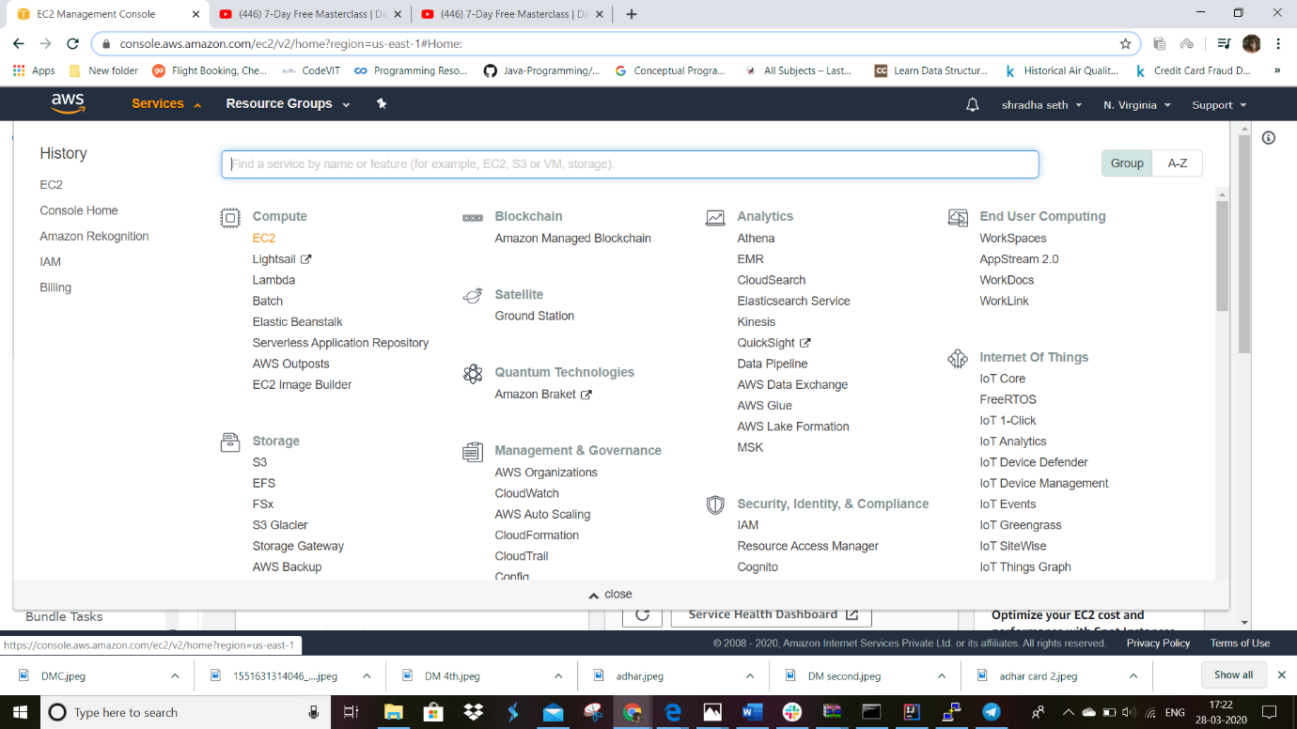

2.select ec2 dashboard.

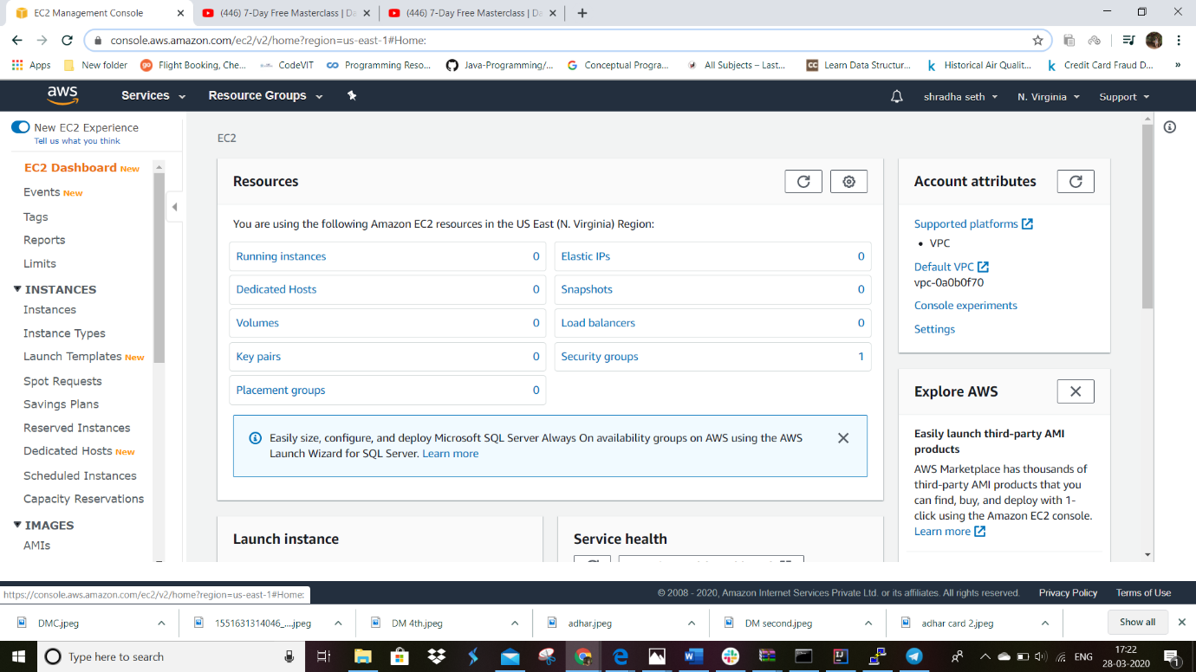

3.scroll down and select launch instance

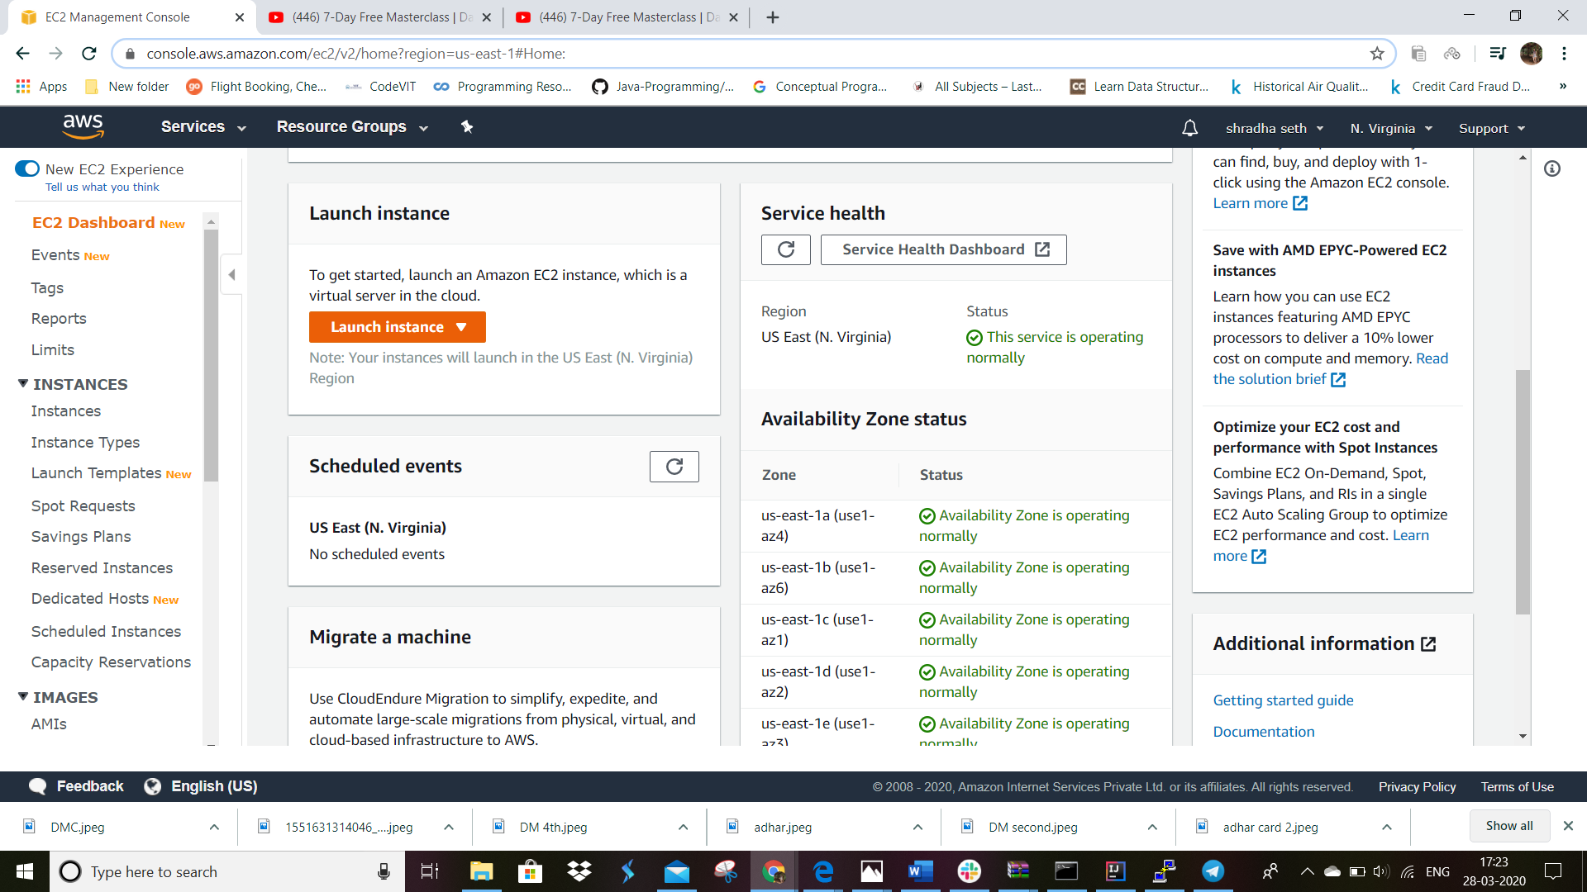

Steps for launching the instances.

I. choose AMI

.select the operatig system lilnux 2.we can select any option but for this project we will be going for this.but make sure to have one with free tier eligibility tag else it will be charged.

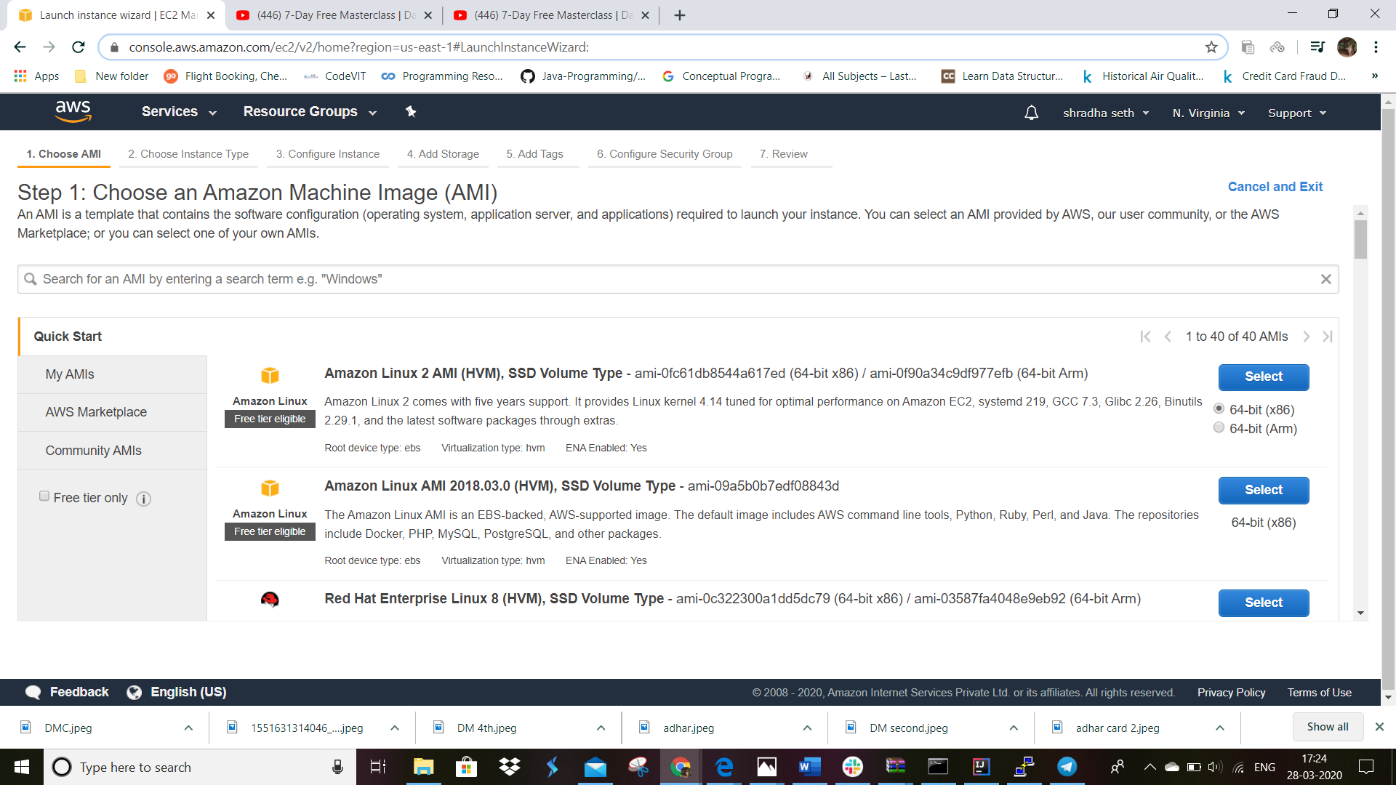

II.choose instance tyoe

select t2 micro to get cpu and ram for this project and then select next:configure Instance details option from the bottom right corner .

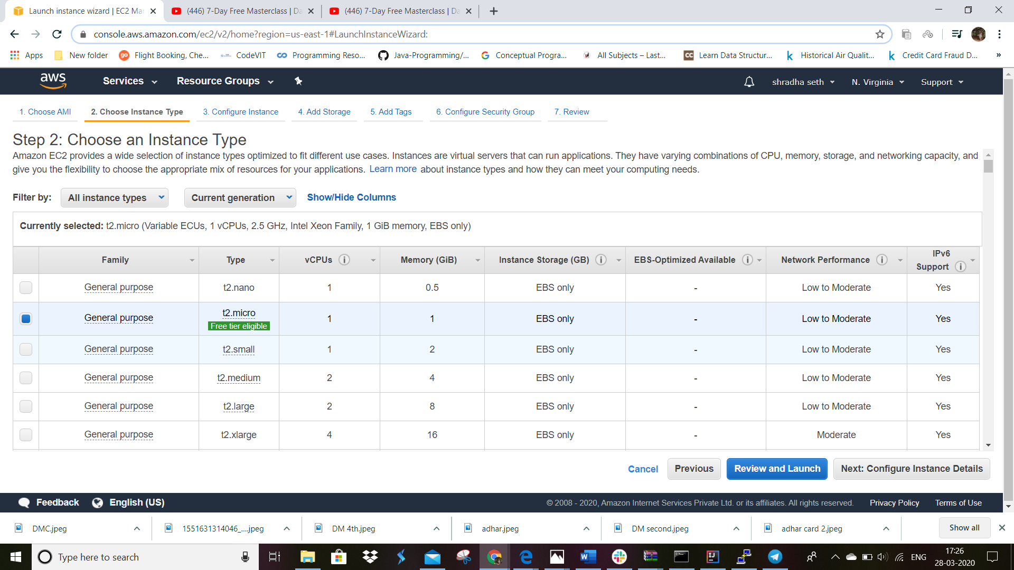

III.configure instance

for now leave this as it is and select add storage

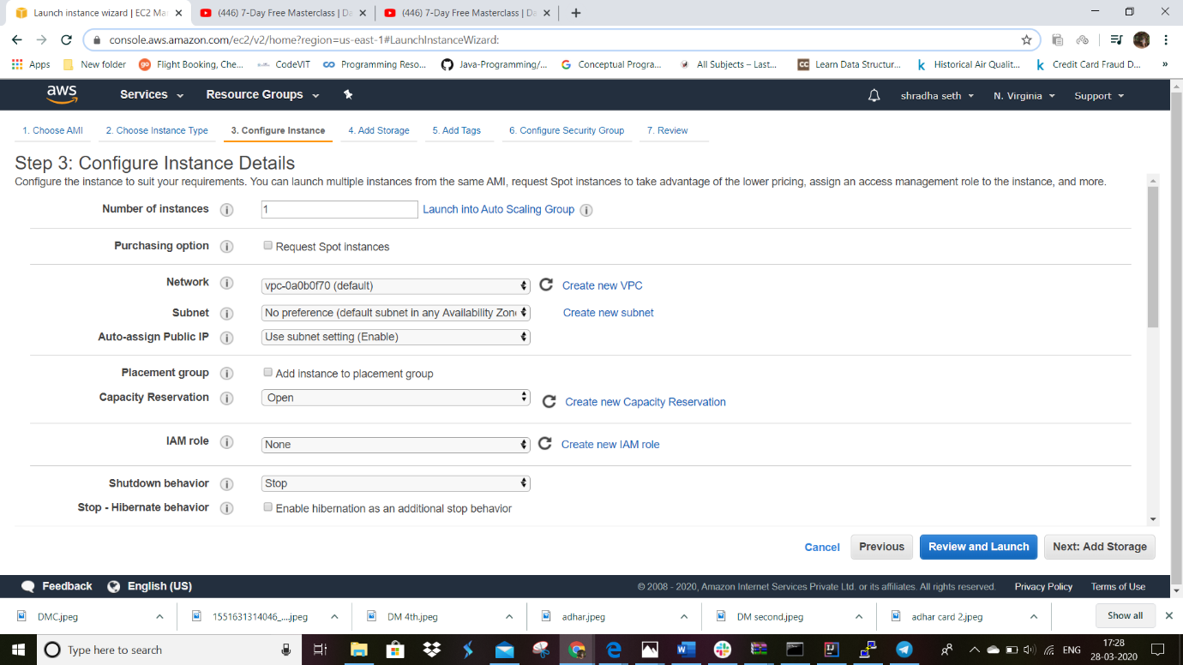

IV.add storage

For this project 8gb is enough. You can extend it till 30 gb in free tier. remeber the type ssh and port 22

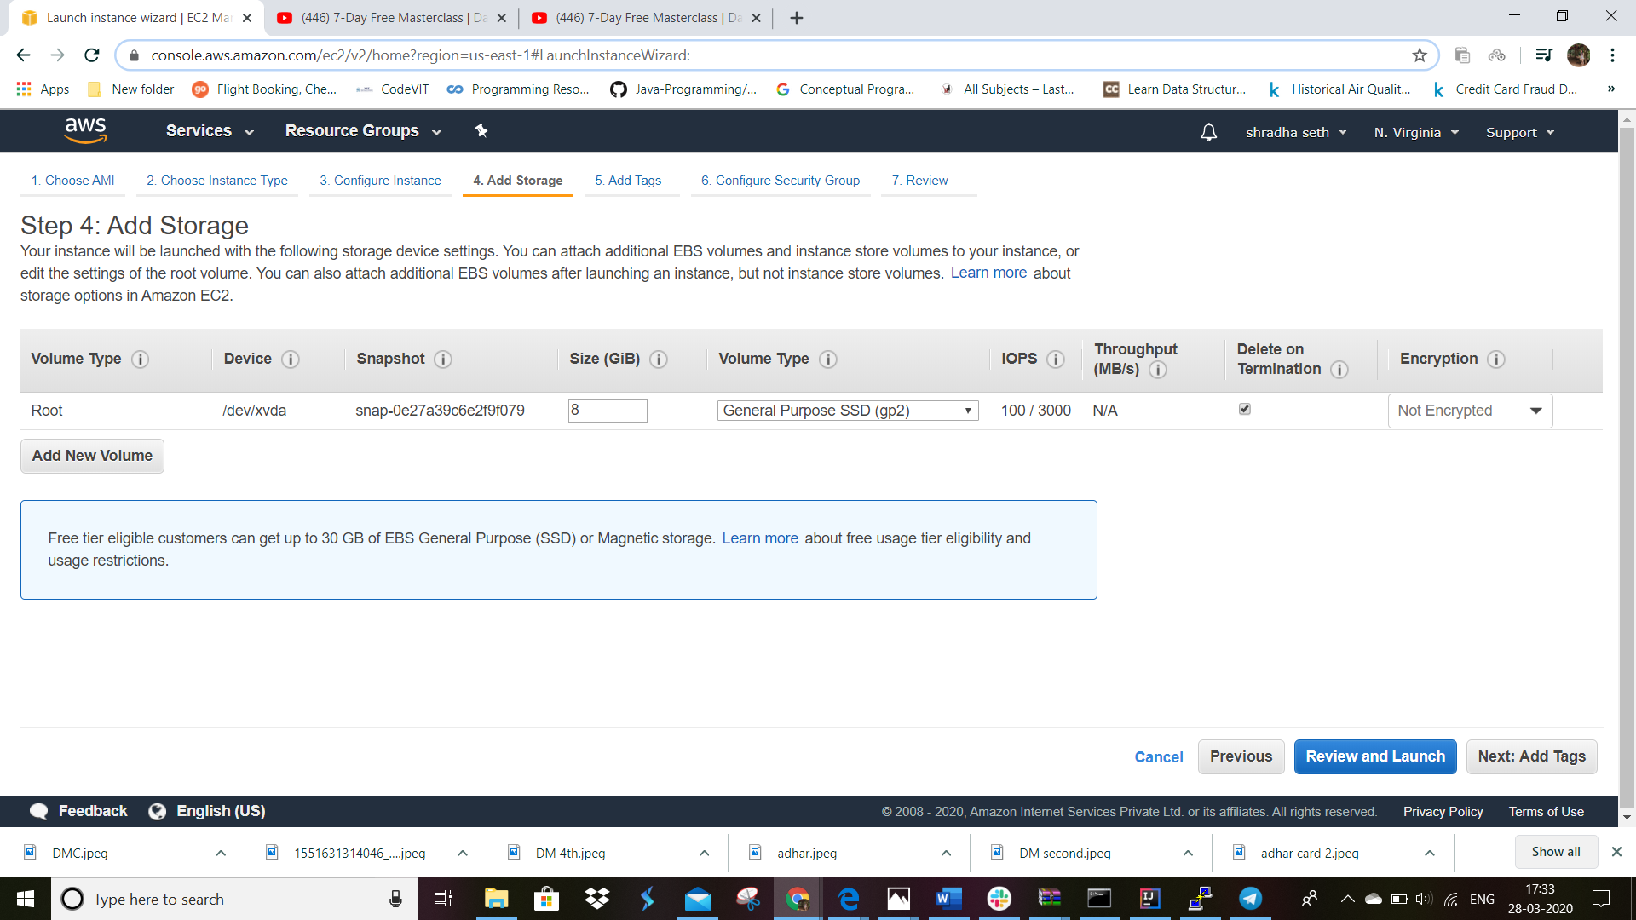

V.add tags

Leave this as it Is for now.

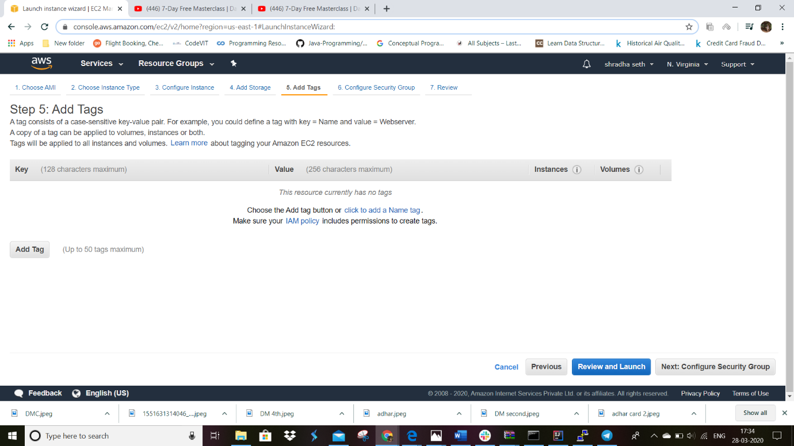

VI.configure security group

Click on review and launch

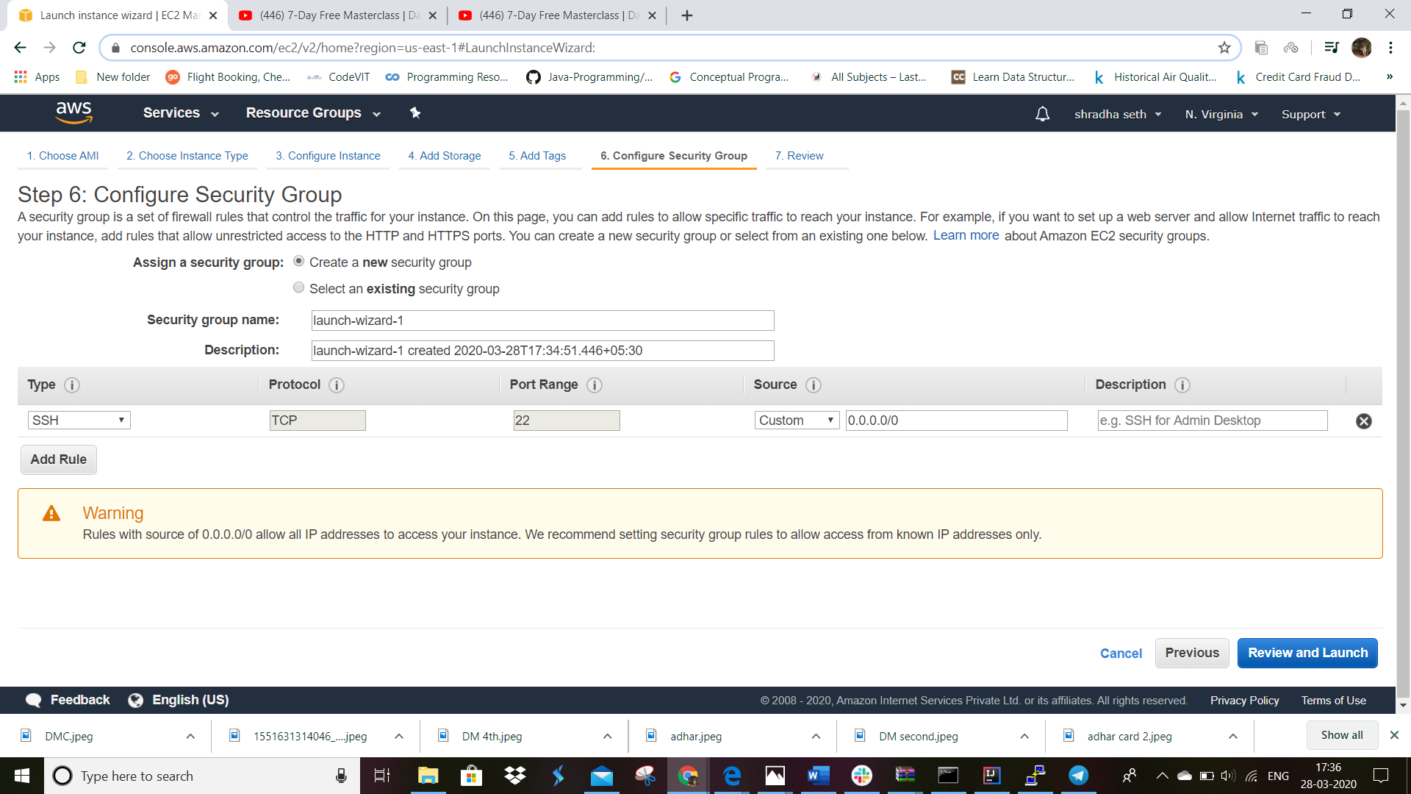

VII.Review

Review it once. and click launch

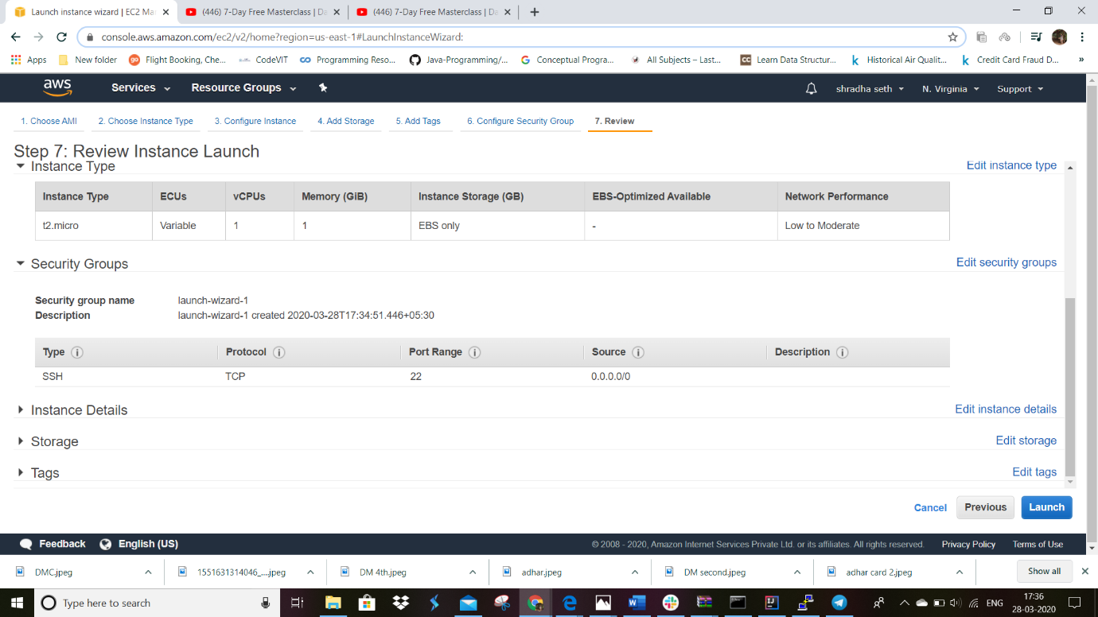

VIII.

In the first option select create a new key pair

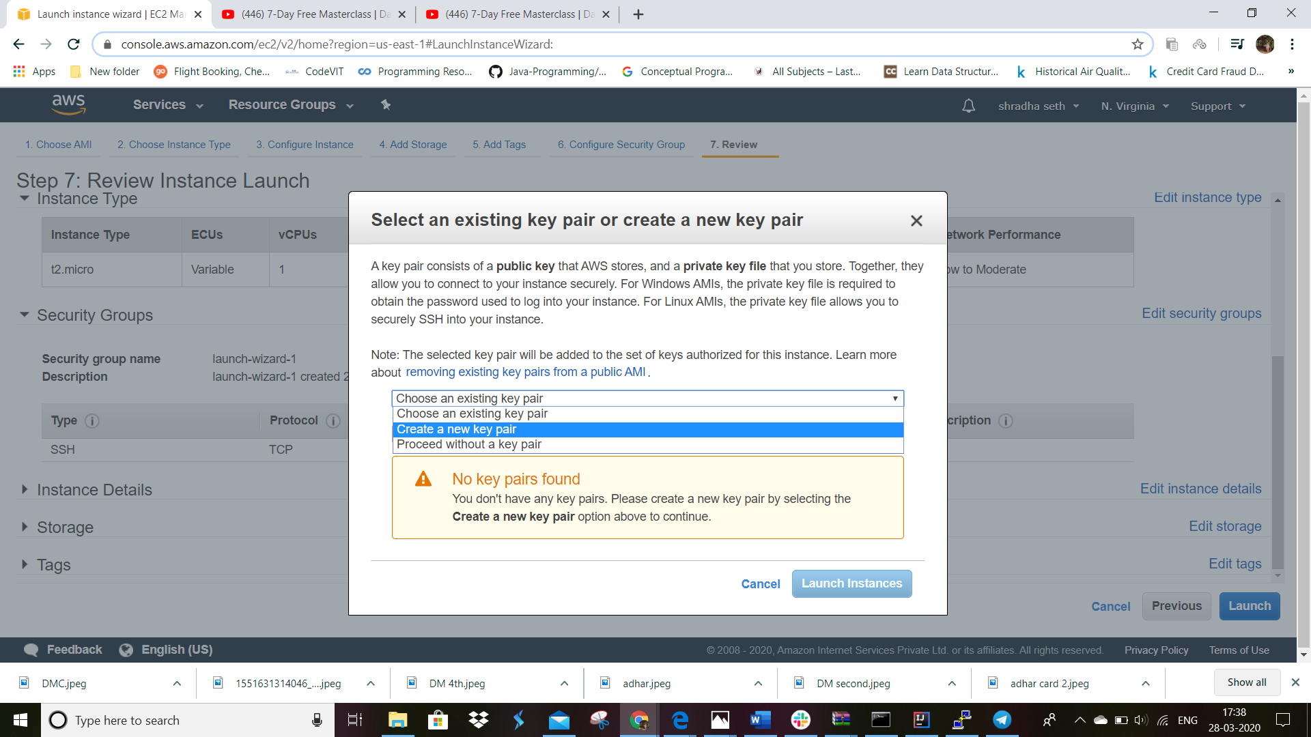

IX.now give the name to your key pair.you can give any name but for this project we are taking it as aws-webinar-key

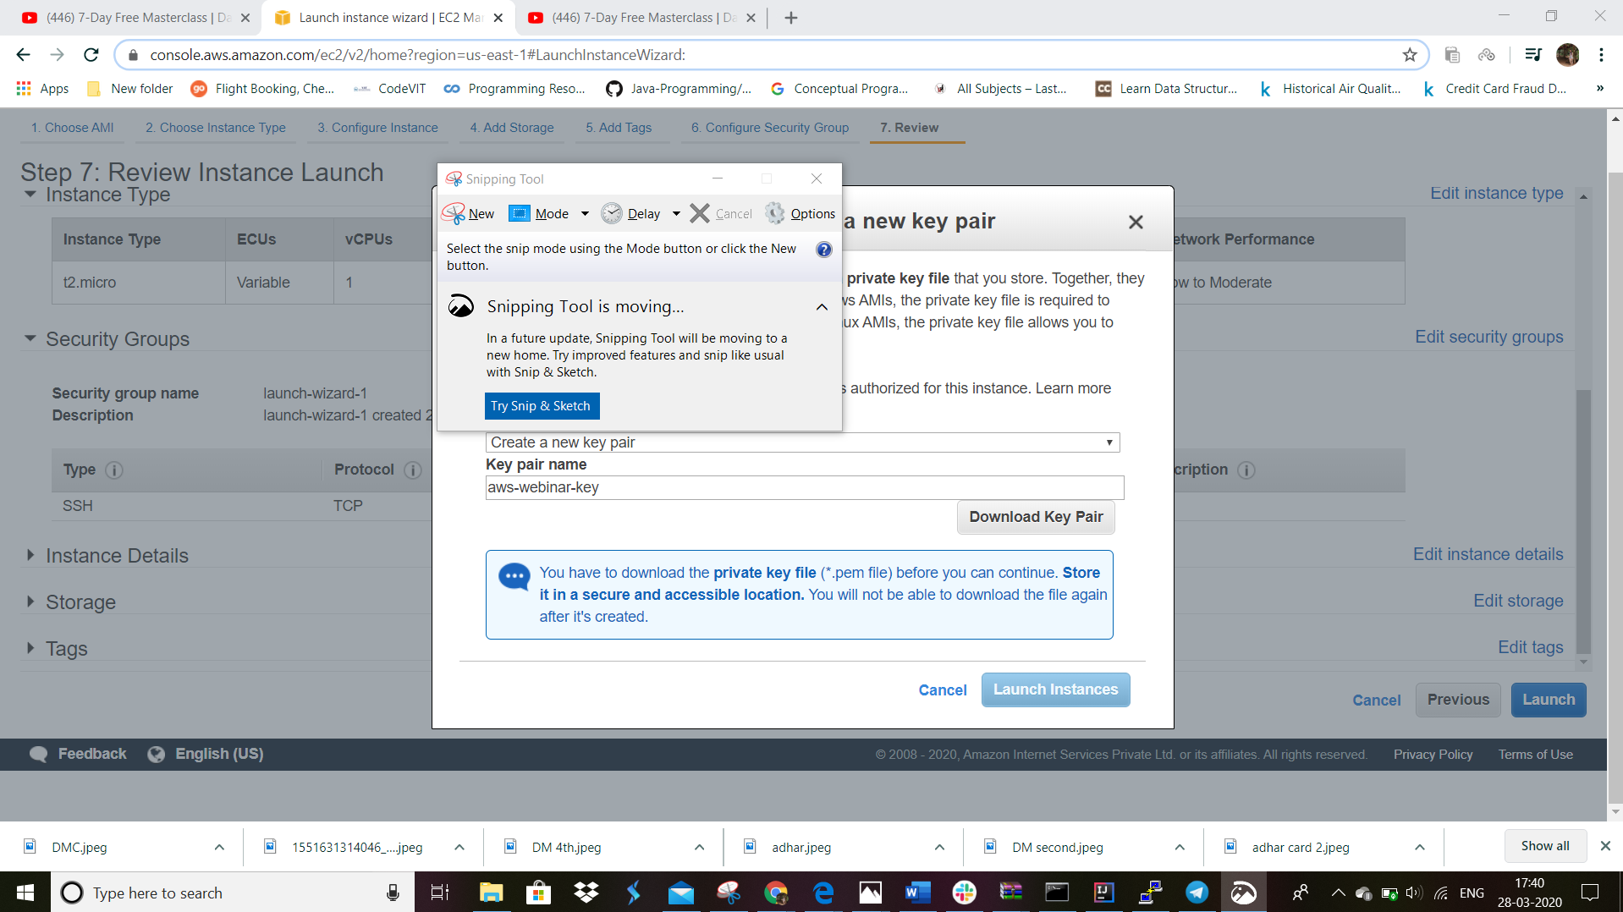

Download the key pair file and select launch instance

Your instance will be launched and will bein running state

4.since this is a linux based instance we will use linux based software called putty for the connection.the next step is to connect your putty to the aws machine we have created.

I.first downlad the puttygen software.

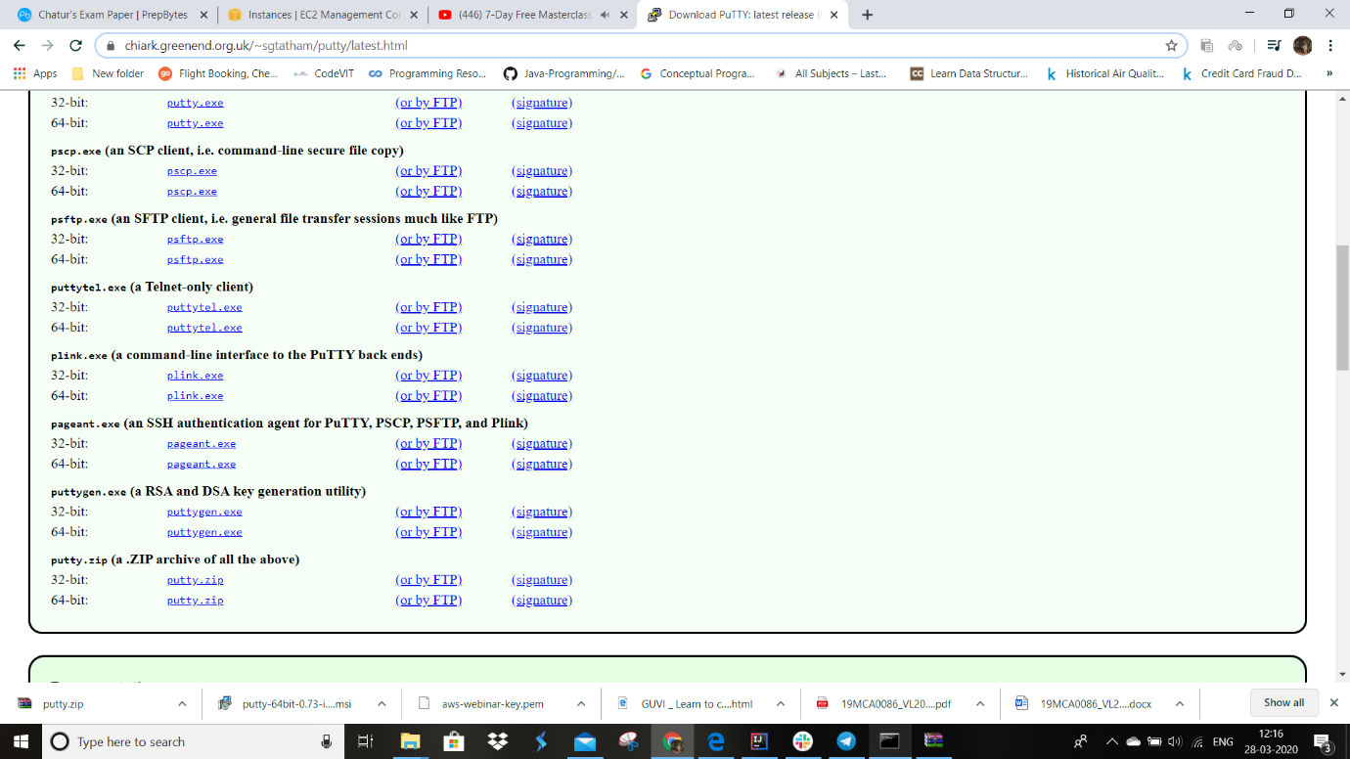

Download puttygen.exe according to your pc configuration.

II.Putty will take the access key in ppk format but we have it in ppm format so first we will change it to ppm now using a command line.

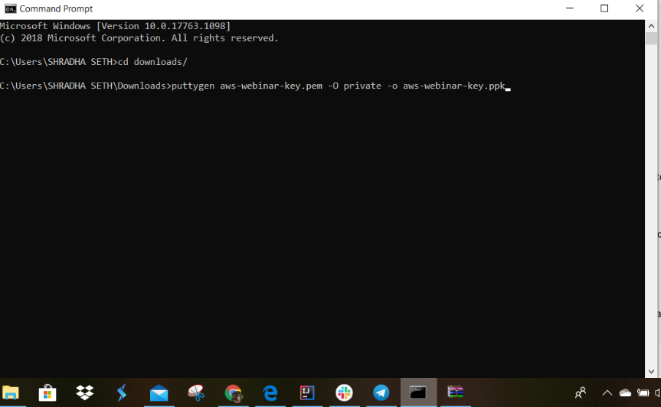

After running this command type exit.

III.now download putty from internet.

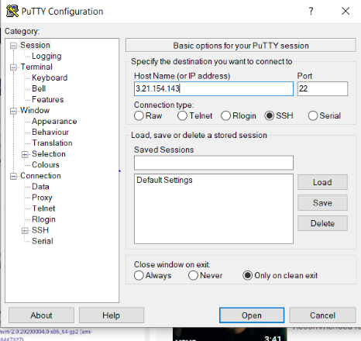

Now in your amazon window screen the decription will be gven and from there copy your ip address and paste it here in putty configuration.and make the port to be 22.

IV.now in the category section on the left side go to SSH option.and select option auth. Select browse option and select aws-webinar-key.ppk file which you have downloaded.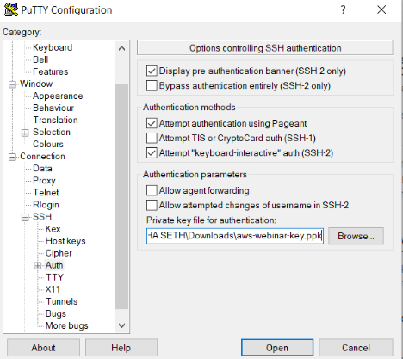

Select open

V. 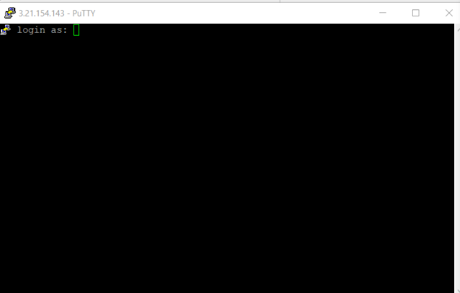

This will appear.if a security allert command prompt appears select accept.

Type username as ec2-user and press enter and wait until it looks llike following

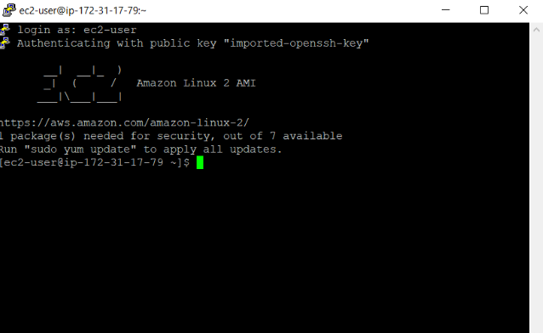

VI.now we will be installing apache server also called as httpd on our virtual machine.this is done to install a service.

Use the command – sudo yum install httpd.

Type this and press enter

Then it will ask for yes or no.type y and your download and install is completed.

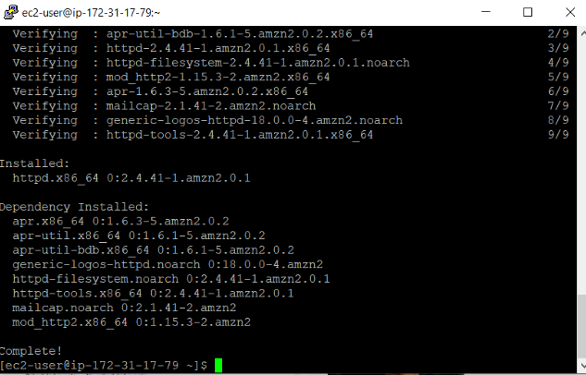

VII.Now type sudo service httpd start and press enter.

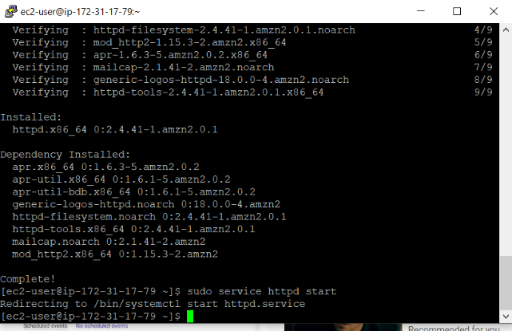

Noe type sudo service httpd service

You will see active(running) showing that it is in running state

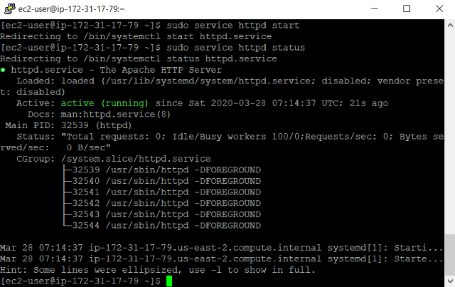

VIII.now type sudo vim/var/www/html/index.html and press enter.

Ix. It will be black screen now press i

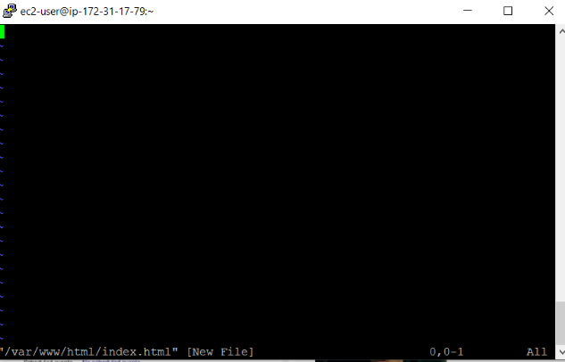

X.you will se insert in the bottom

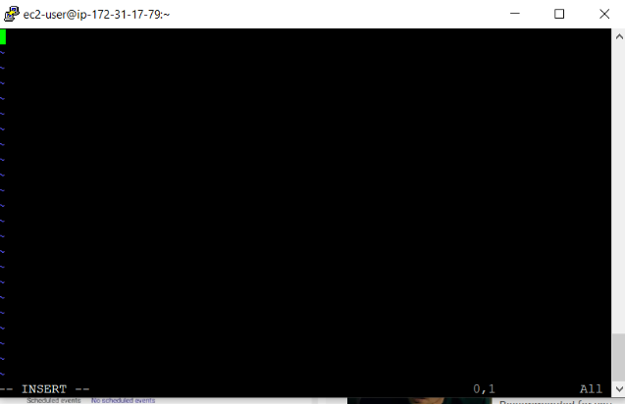

Type anything like hello “from shradha”.

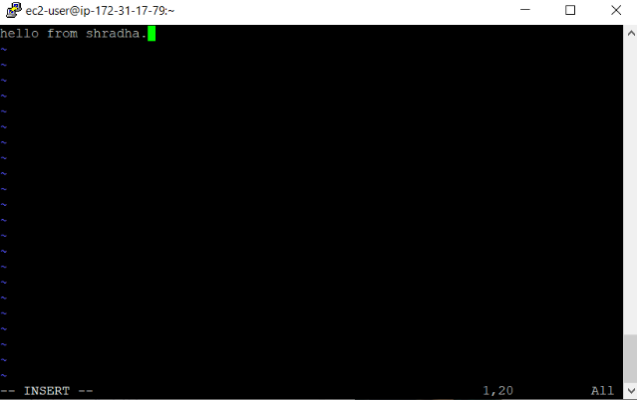

XI.after typing a text press esc :wq.the following screen will appear

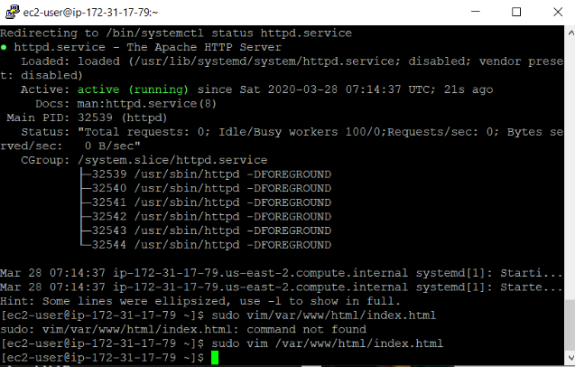

X.now we also neec to allow traffic from http also so for that go to ypur instance s again ain amazon window.at the bottom in the description box there will be option of security group.select security group.again click on security group.

In inbound rules click on edit and then click on add

In type select HTTP and select source as anywhere.

now agin copy the ip address you copied before and put it in the search bar og your browser and press enter.your text will appear.

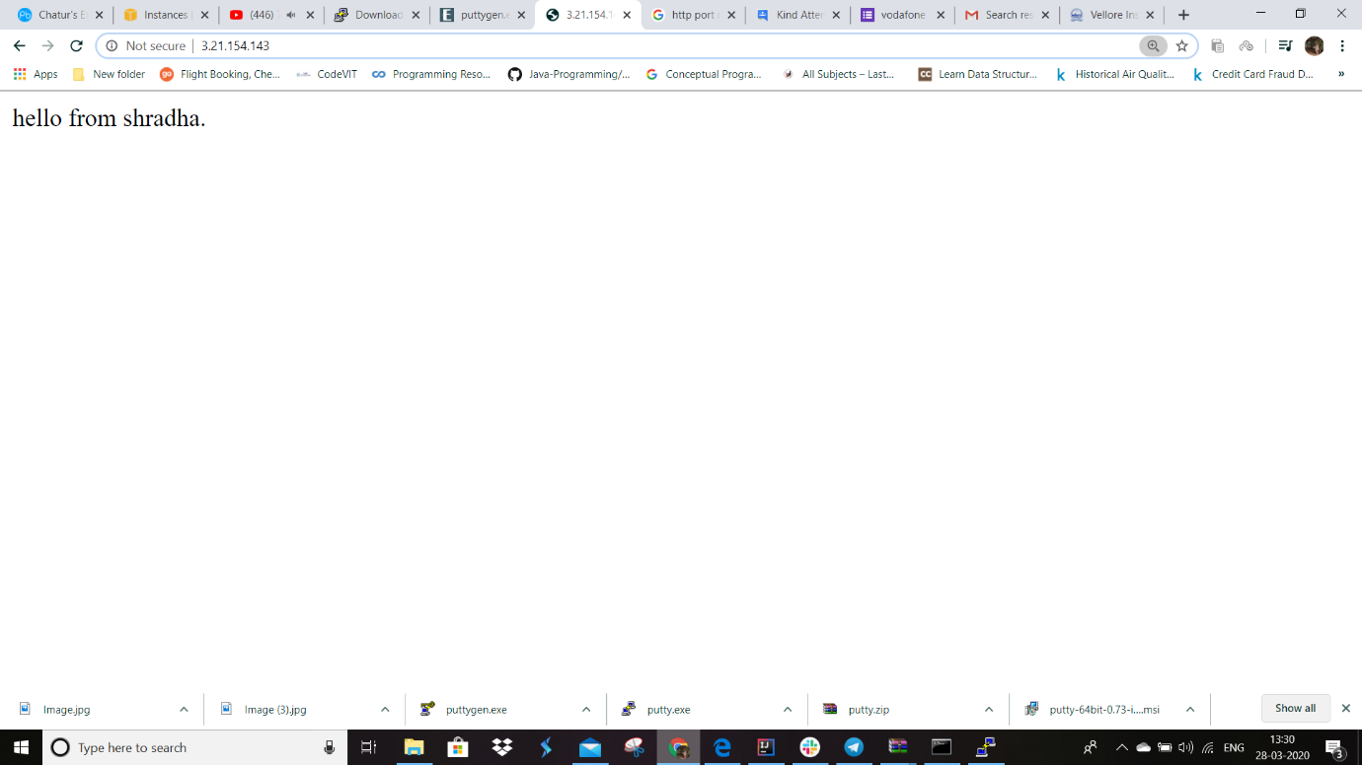

5.now go to services and select s3.select create bucket option.

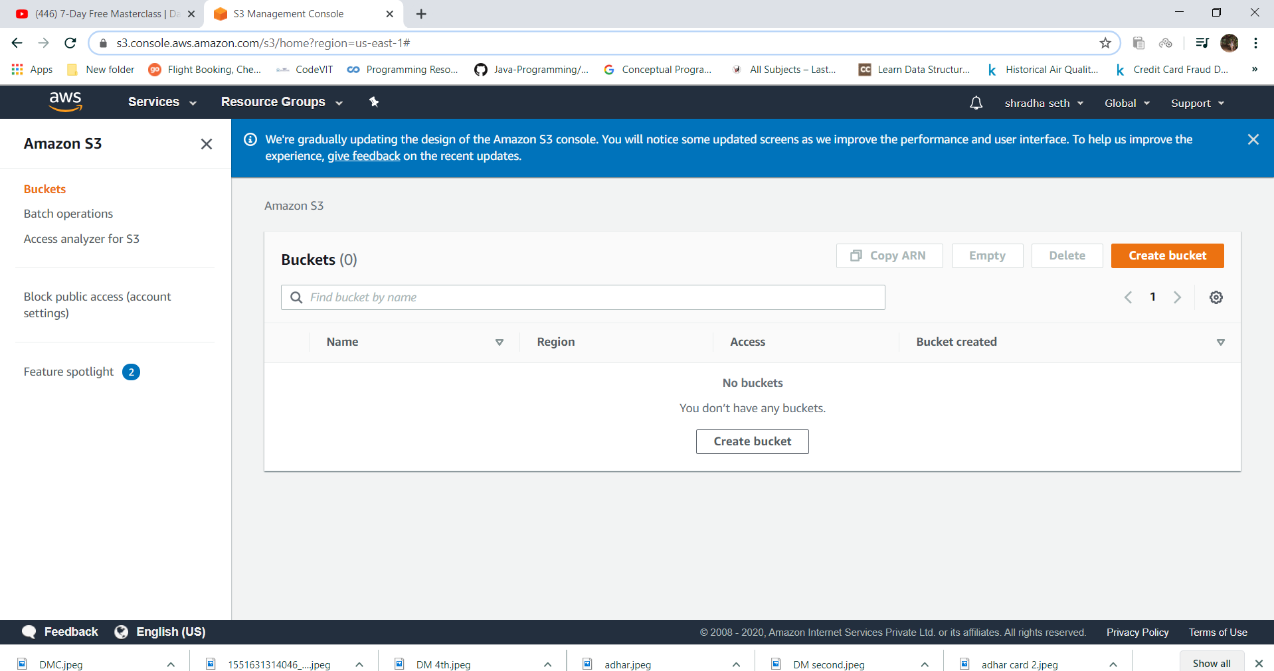

6.type your bucket name.like “awsbucket12345”.

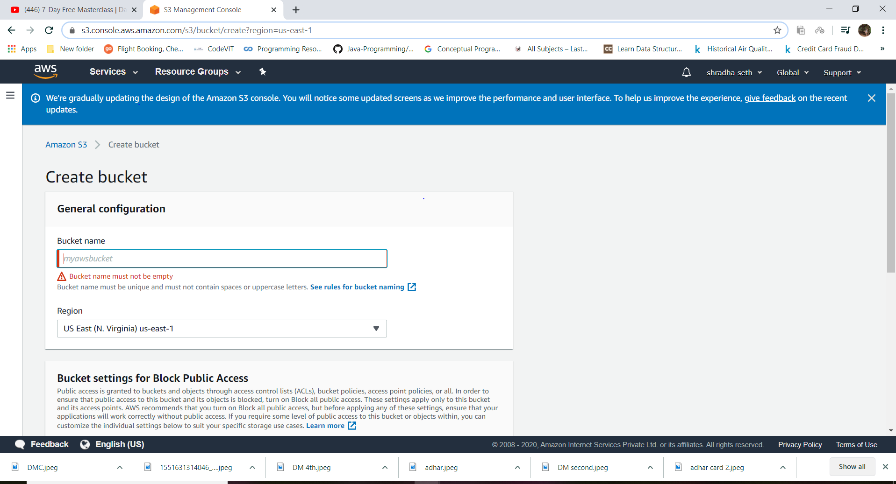

Ater going ahead.the following screen appears

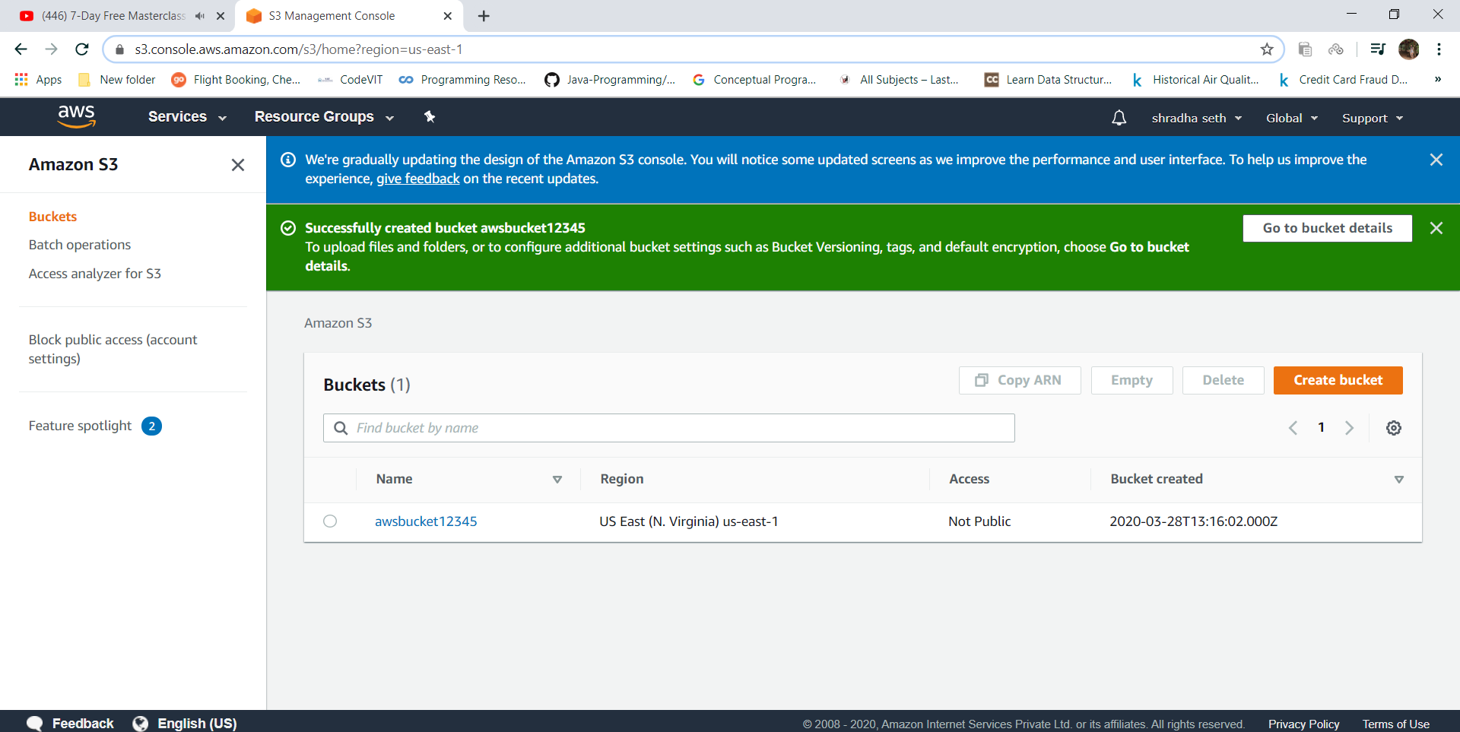

7.select your bucket name

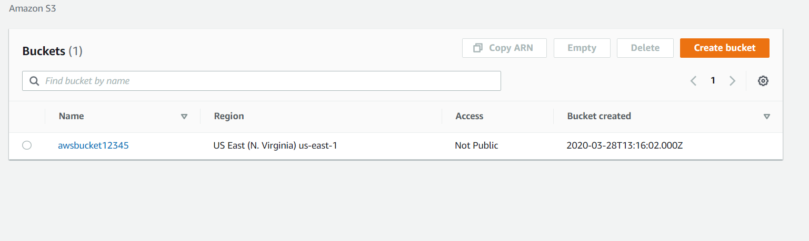

8.now you have an empty bucket so to upload some files go to upload option.and select a file

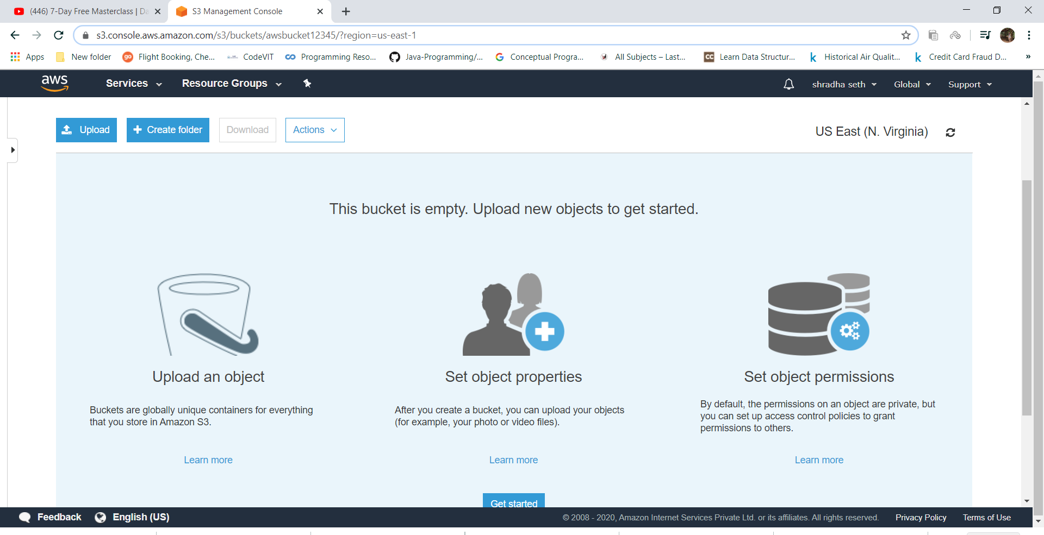

9.for that create a html file also.

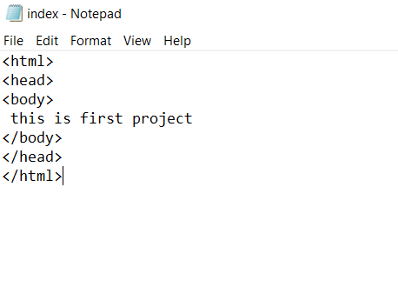

10.click on add file

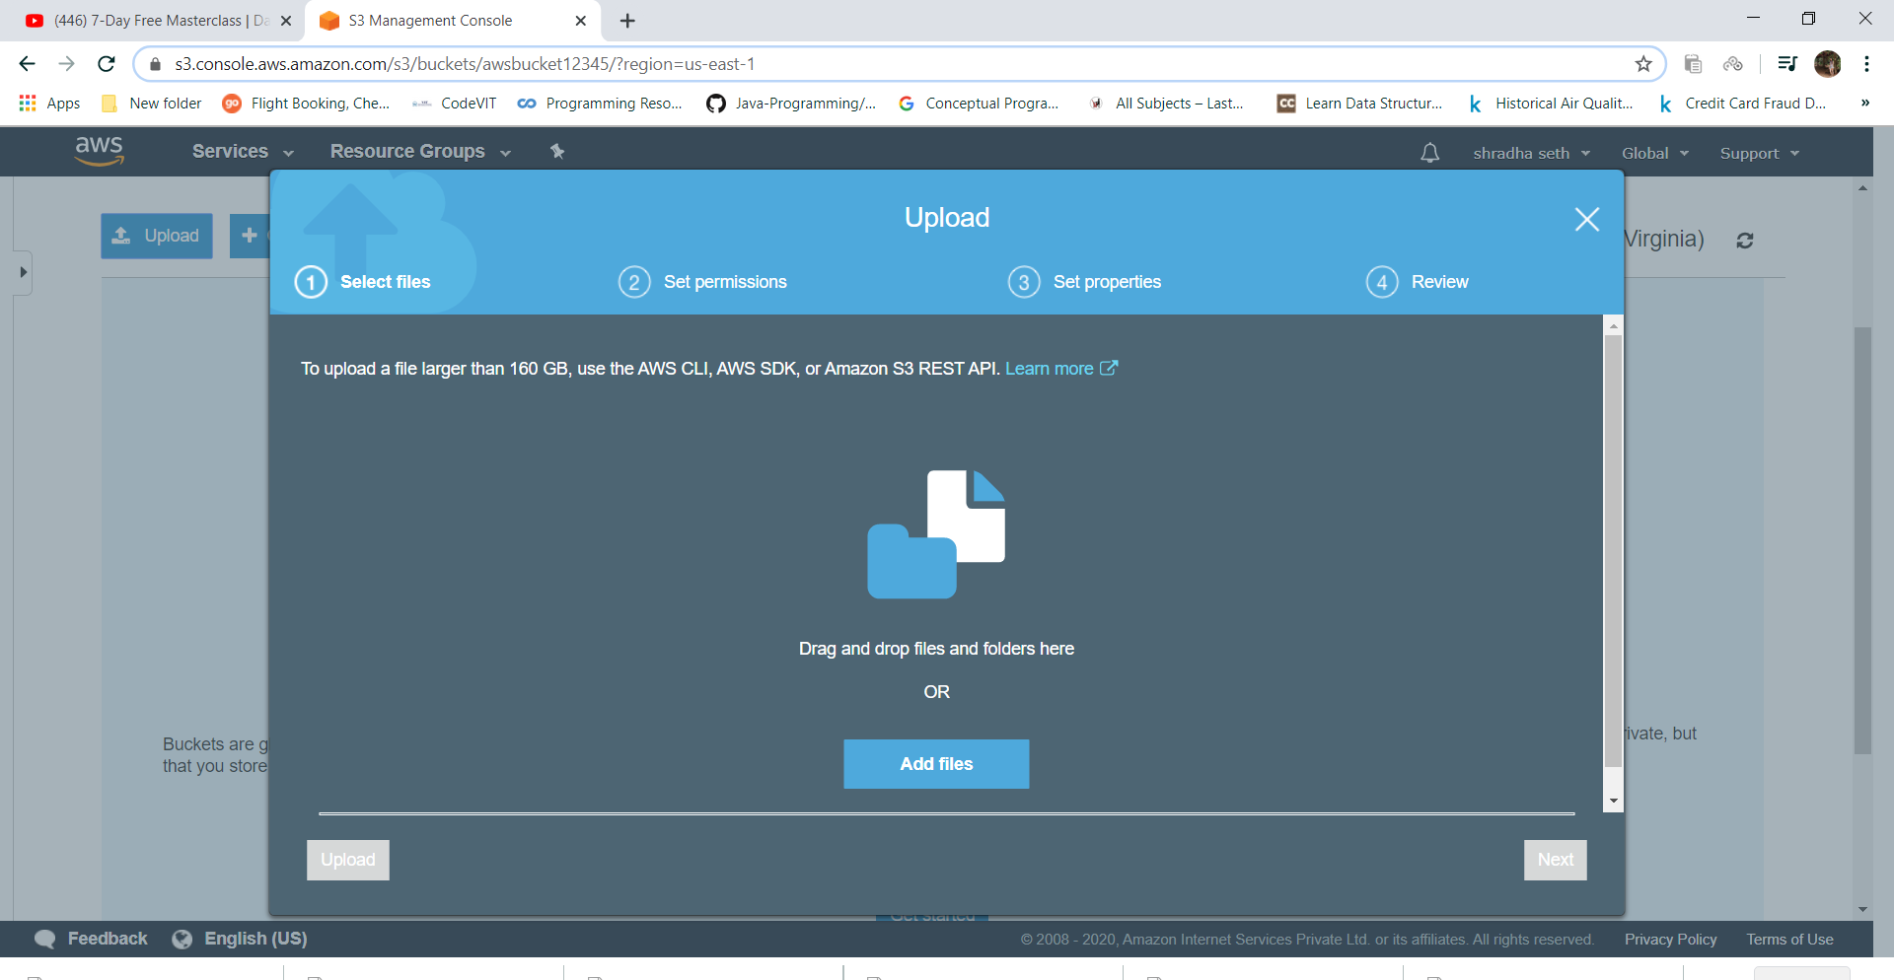

11.select index.html and click next.

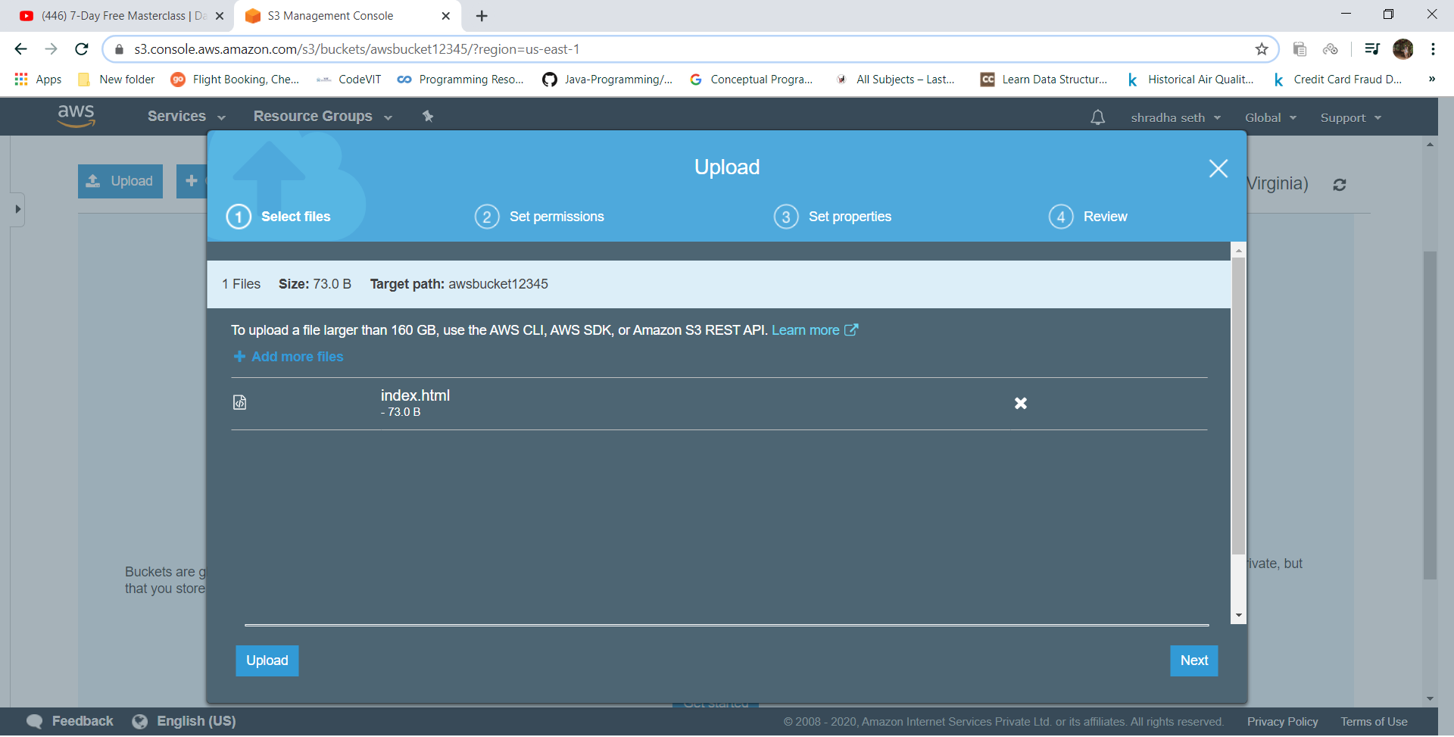

12.againn select next

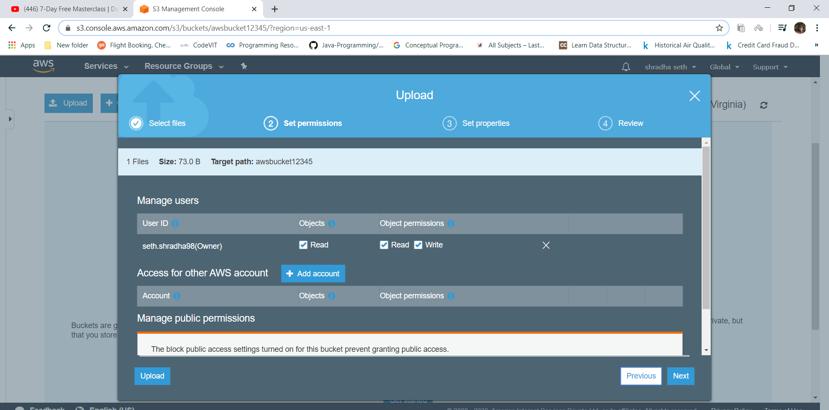

13.click next

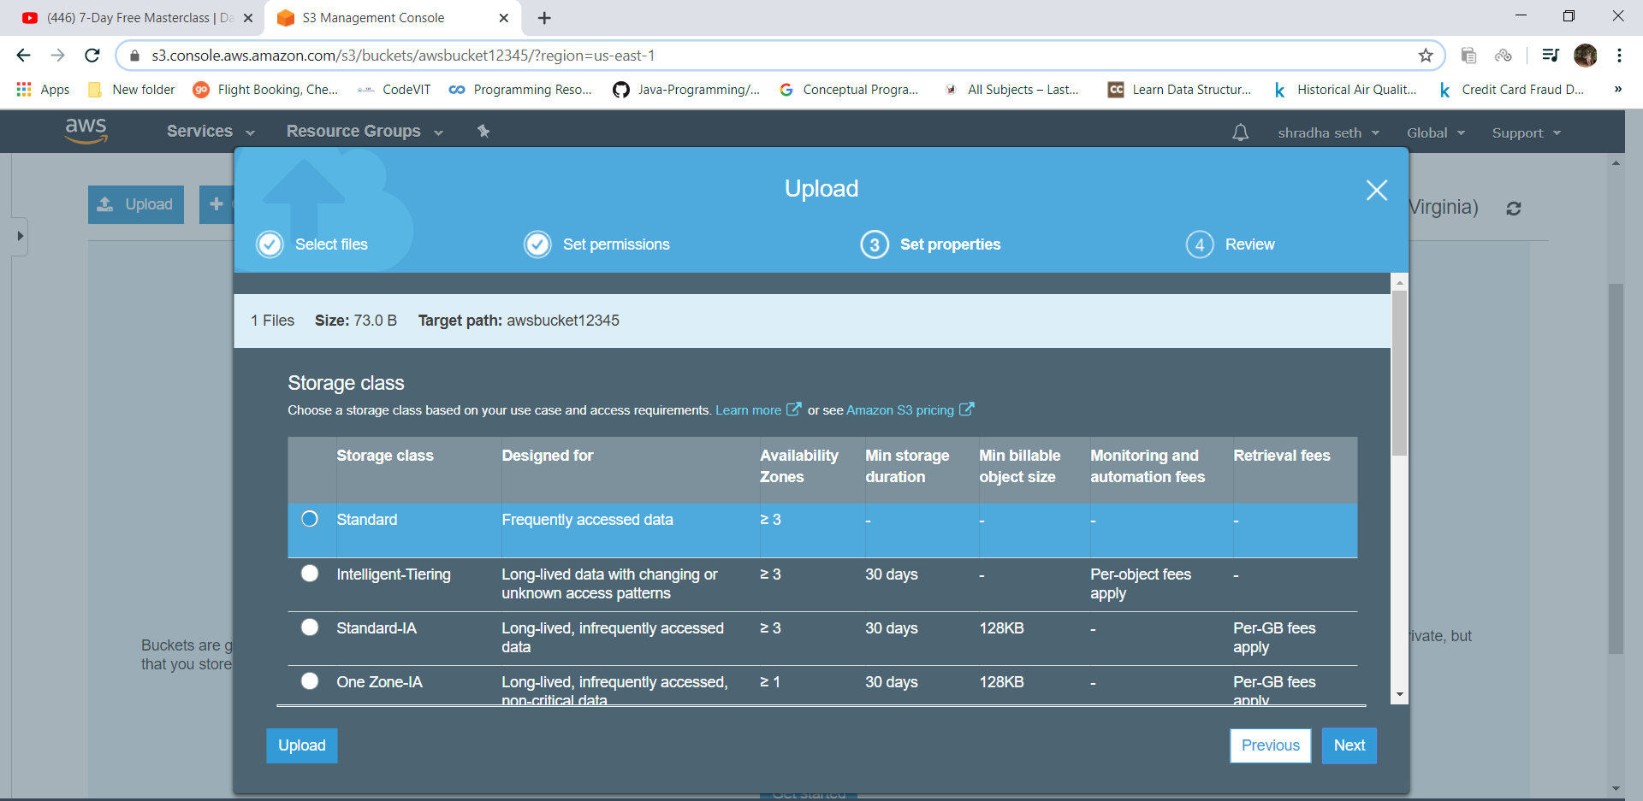

14.click upload

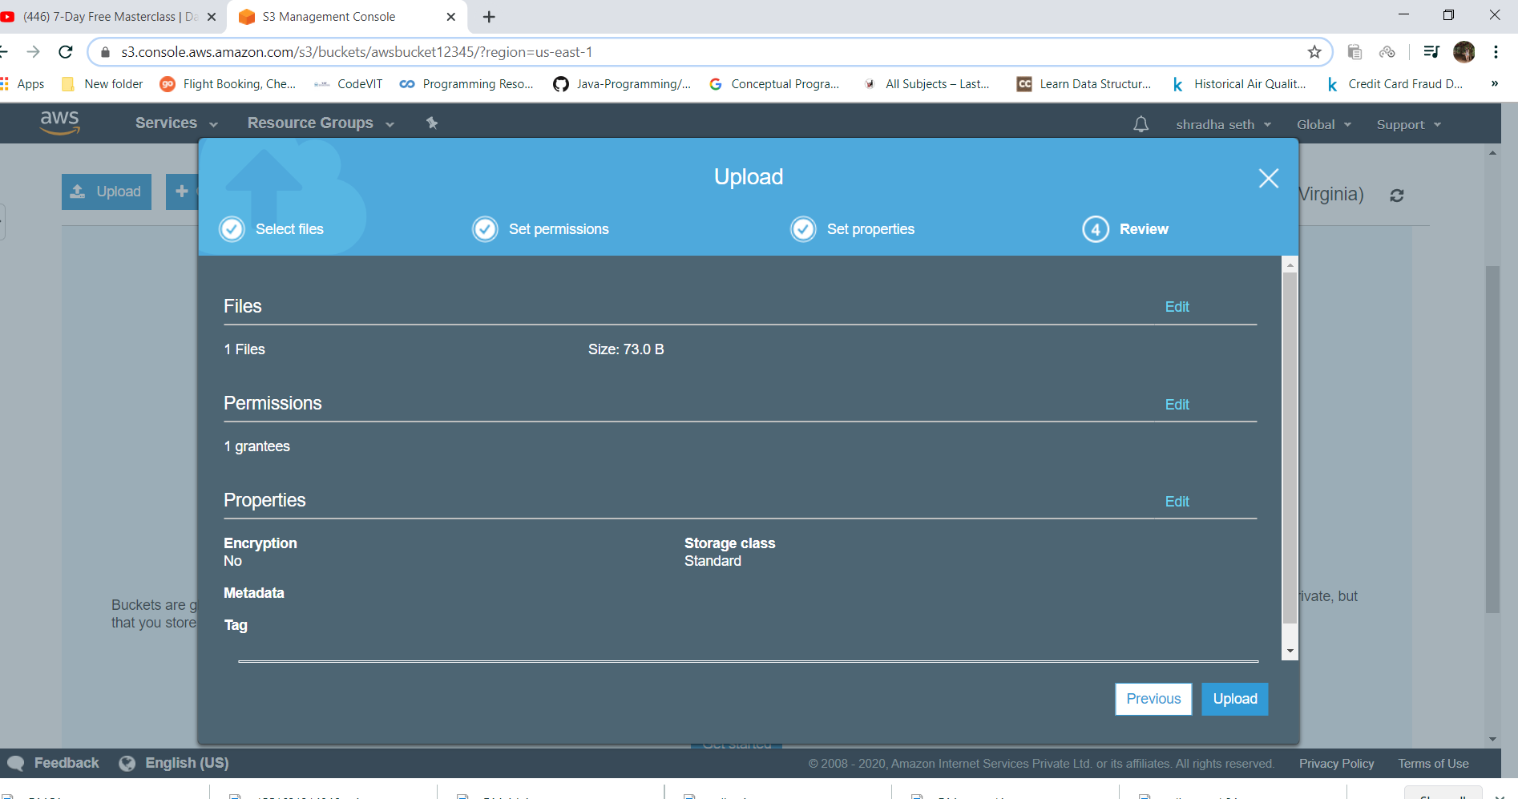

15.your file will be uploaded

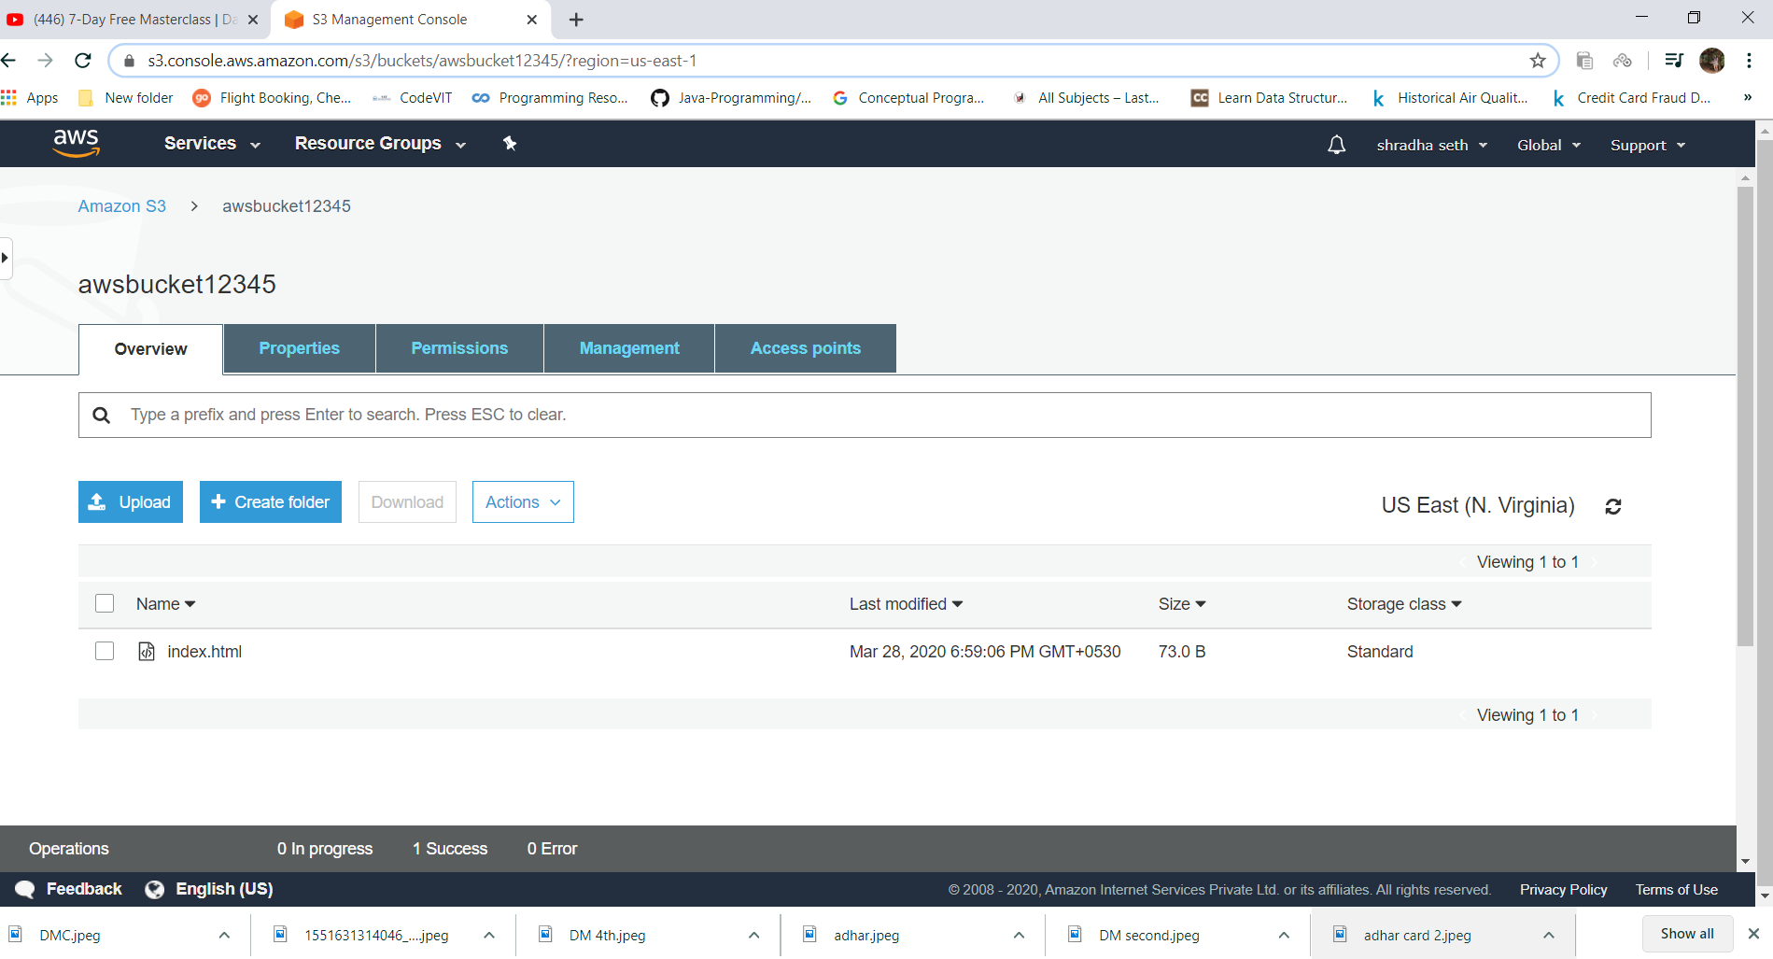

16.now g o to properties and select static web hosing to enable it.

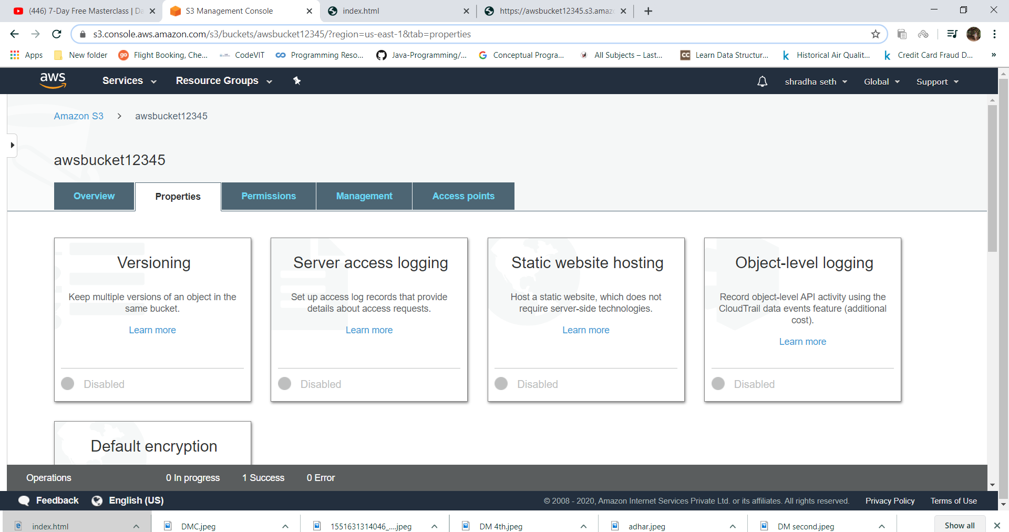

17.affter selecting this select use this bucket to host a website and type index.html in index document and select save.

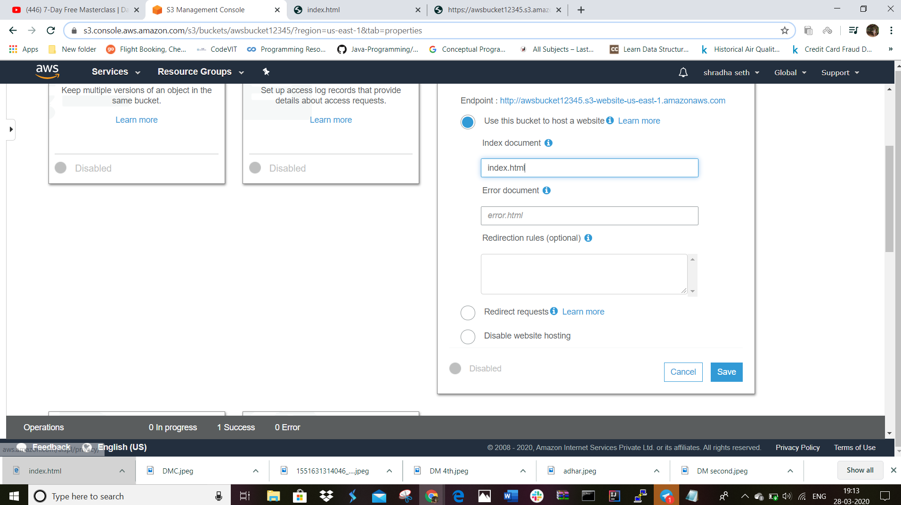

18.now go to permissions.click on edit and uncheck the already check box.

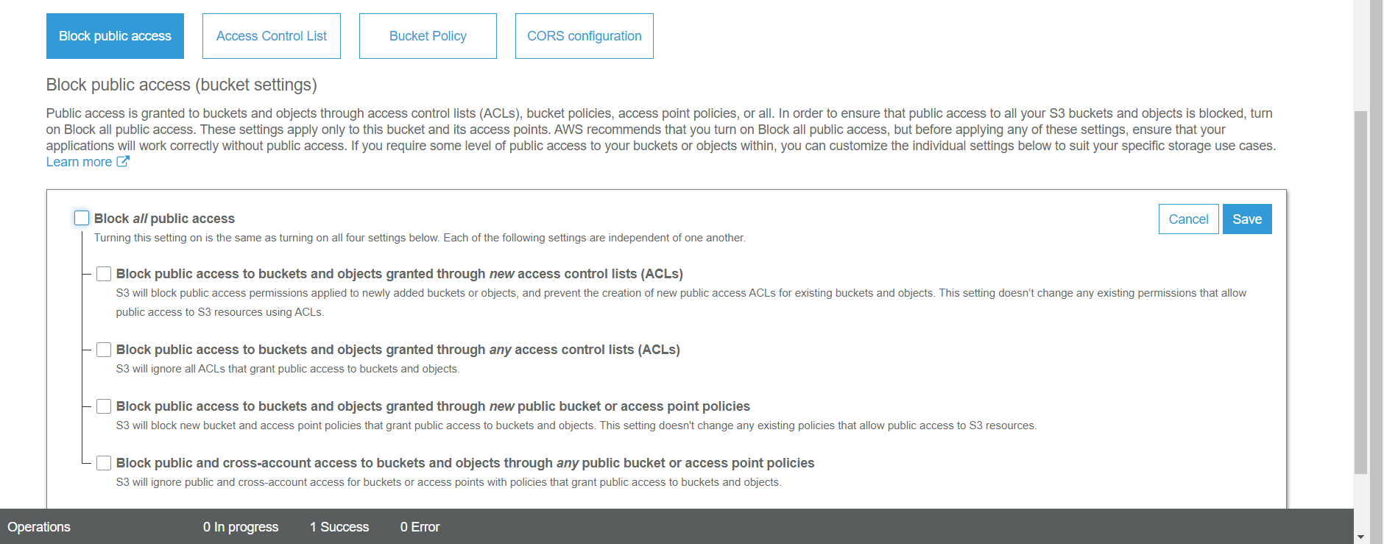

19.click on save and type confirm. now go to the index.html object and select option make it public.

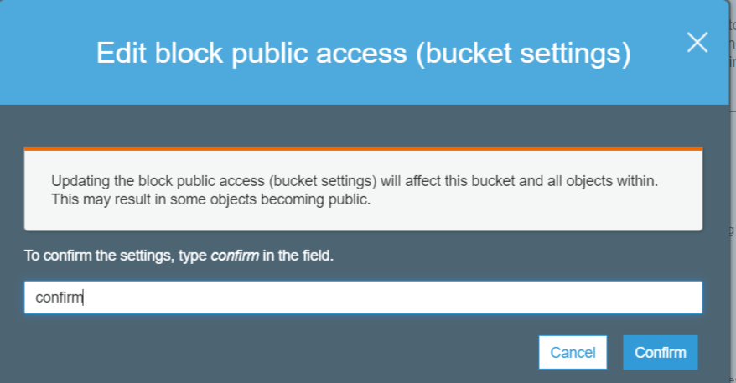

Installimnmg php

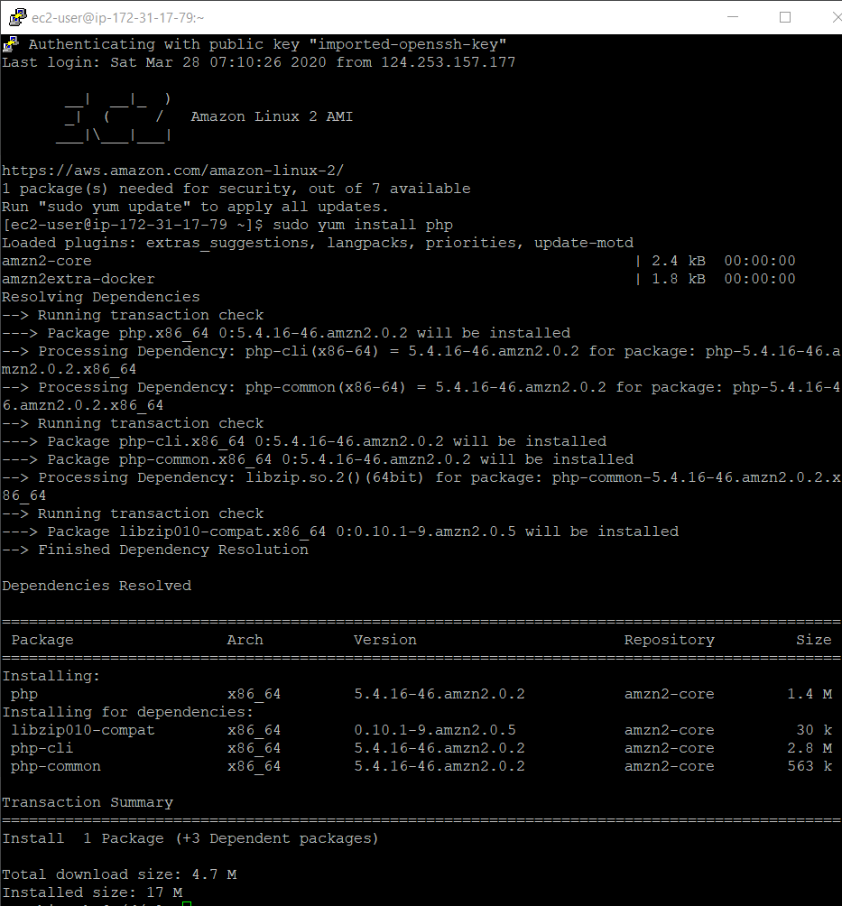

Install php

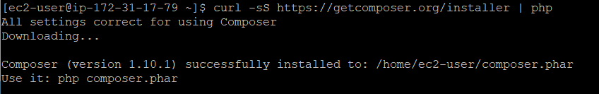

Download image

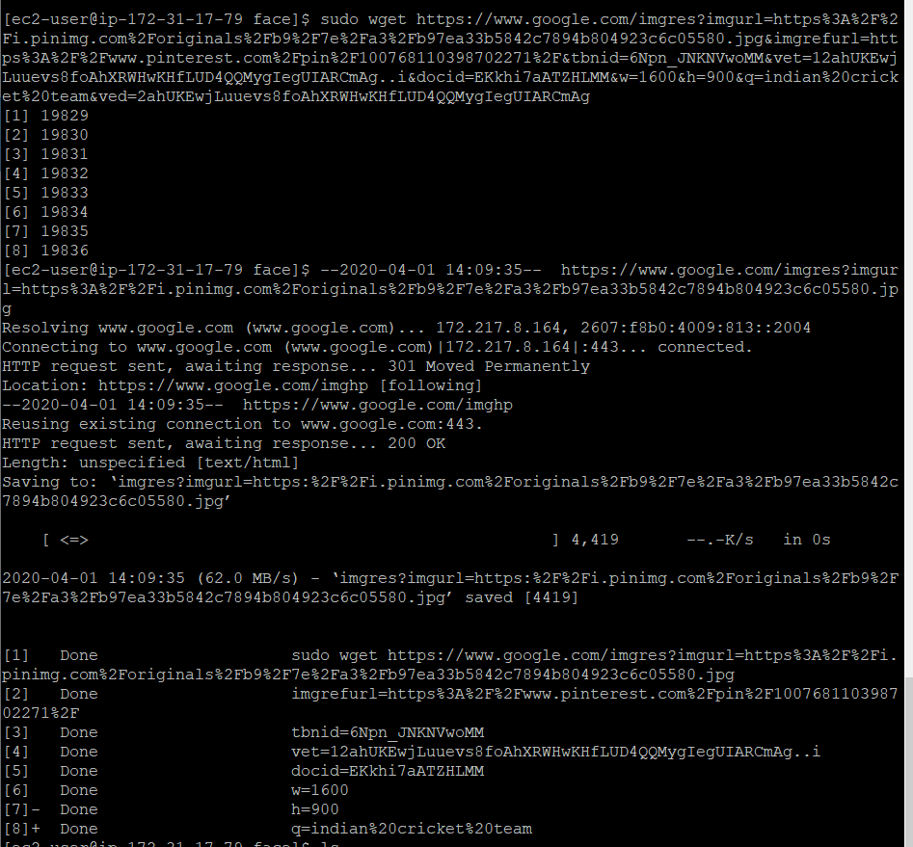



**Some screenshots and last few steps are not there because of the problem in uploading the image.it wasn’t there in the troubleshoot guide.i have even email you regarding the same and posted my doubt through that form also but I didn’t got any reply. So for now plz consider this and I will still wait for the reply of my error as I want to complete this project.**